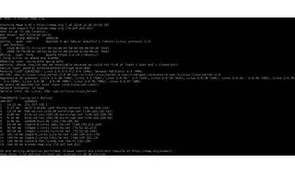

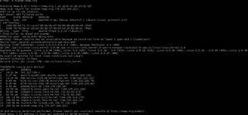

Explore

Certainly! [In a nutshell, **Nmap** is a powerful open-source tool used by penetration testers to **scan IP addresses and ports**, detect installed applications, and identify vulnerabilities in computer systems1](https://www.freecodecamp.org/news/what-is-nmap-and-how-to-use-it-a-tutorial-for-the-greatest-scanning-tool-of-all-time/). Here are **five free reference links** where you can learn more about Nmap and its usage:

1. [**What is Nmap and How to Use it**](https://www.freecodecamp.org/news/what-is-nmap-and-how-to-use-it-a-tutorial-for-the-greatest-scanning-tool-of-all-time/): A comprehensive tutorial covering Nmap’s core features and useful commands[1](https://www.freecodecamp.org/news/what-is-nmap-and-how-to-use-it-a-tutorial-for-the-greatest-scanning-tool-of-all-time/).
2. [**What is Penetration Testing**](https://www.cloudflare.com/learning/security/glossary/what-is-penetration-testing/): Learn about penetration testing, which involves ethical hackers identifying and exploiting vulnerabilities in computer systems[2](https://www.cloudflare.com/learning/security/glossary/what-is-penetration-testing/).
3. [**Nmap for Sysadmins**](https://www.pentestpartners.com/security-blog/nmap-for-sysadmins/): Explore how Nmap can be handy for IT managers and system administrators to identify security issues on their networks[3](https://www.pentestpartners.com/security-blog/nmap-for-sysadmins/).
4. [**How to Find the Best Nmap Scan**](https://www.eccouncil.org/cybersecurity-exchange/penetration-testing/best-nmap-scan-for-pen-test/): Discover the best Nmap scans for penetration testing initiatives and gain insights into effective usage[4](https://www.eccouncil.org/cybersecurity-exchange/penetration-testing/best-nmap-scan-for-pen-test/).
5. [**Nmap Cheat Sheet**](https://www.stationx.net/nmap-cheat-sheet/): A handy cheat sheet with essential Nmap commands and flags for quick reference[5](https://www.stationx.net/nmap-cheat-sheet/).

Feel free to explore these resources to enhance your understanding of Nmap! 🛡️🔍